**USER AND OPERATING SYSTEM INTERFACE**

There are two fundamental approaches for users to interface with the operating system. One technique is to provide a command-line interface or command interpreter that allows users to directly enter commands that are to be performed by the operating system. The second approach allows the user to interface with the operating system via a graphical user interface or GUI.

**1)Command Interpreters:**

Some operating systems include the command interpreter in the kernel. Others, such as Windows XP and UNIX, treat the command interpreter as a special program which can be initiated by user. On systems with multiple command interpreters to choose one from them, the interpreters are known as shells.

**Ex:** On UNIX and Linux systems, there are several different shells a user may choose from including the Bourne shell, C shell, Bourne-Again shell (BASH), the Korn shell etc. Below figure shows the Bourne shell command interpreter being used on Solaris 10.

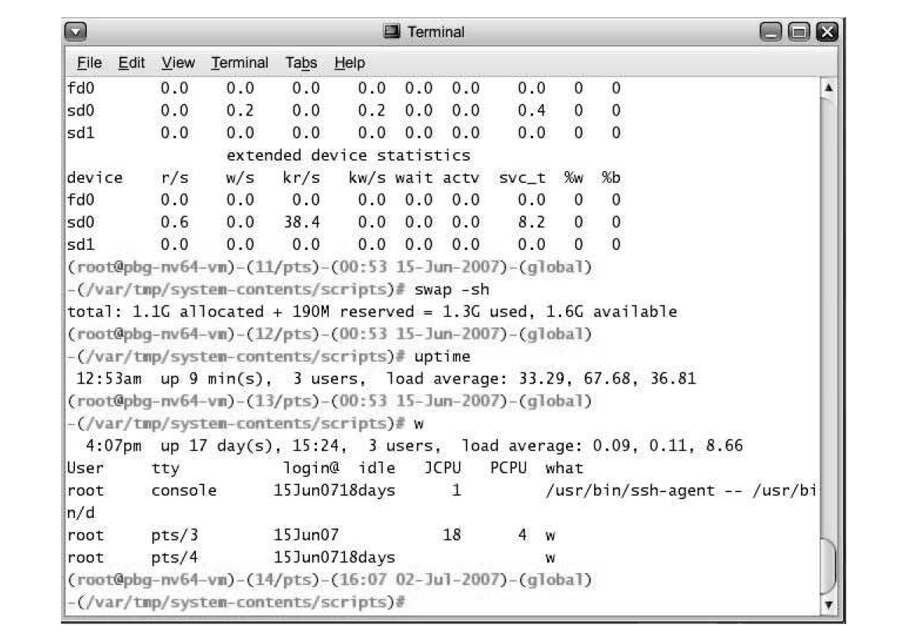

Fig: Bourne shell command interpreter in Solaris 10

The main function of the command interpreter is to get and execute the next user-specified command. Many of the commands given at this level manipulate files: create, delete, list, print, copy, execute, and so on. There are two general ways in which these commands can be implemented.

In one approach, the command interpreter itself contains the code to execute the command.

Ex: A command to delete a file

* Then command interpreter to jump to a section of its code
* that sets up the parameters
* and makes the appropriate system call.

An alternative approach—used by UNIX, among other operating systems —implements most commands through system programs. In this case, the command interpreter does not understand the command in any way; it merely uses the command to identify a file to be loaded into memory and executed.

**Ex:** UNIX command to delete a file rm file.txt

* Then it would search for a file called rm.
* load the file into memory.
* and execute it with the parameter file .txt.

The function associated with the rm command would be defined completely by the code in the file rm. In this way, programmers can add new commands to the system easily by creating new files with the proper names. The command-interpreter program, which can be small, does not have to be changed for new commands to be added.

**2)Graphical User Interface:**

A second strategy for interfacing with the operating system is through a user- friendly graphical user interface or GUI. Rather than having users directly enter commands via a command-line interface, a GUI provides a mouse-based window-and-menu system as an interface. The user moves the mouse to position its pointer on images, or icons, on the screen (the desktop) that represent programs, files, directories, and system functions. Depending on the mouse pointer's location, clicking a button on the mouse can invoke a program, select a file or directory known as a folder or pull down a menu that contains commands.

Graphical user interfaces first appeared due in part to research taking place in the early 1970s at Xerox PARC research facility. The first GUI appeared on the Xerox Alto computer in 1973.